Smart Measuring Device
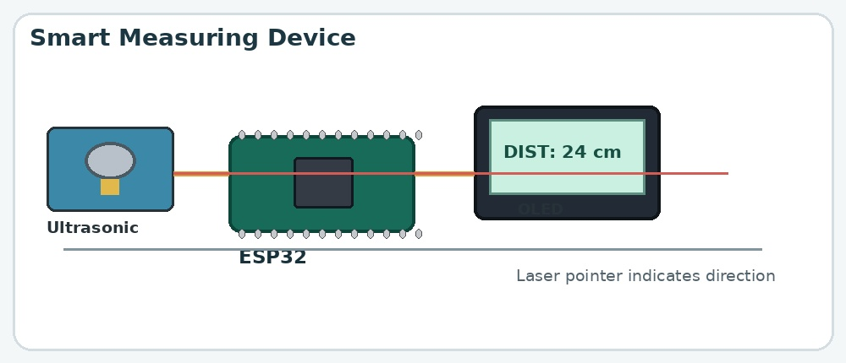

Aim
To measure the distance between the device and an object and display the measurement on an OLED screen.

What is the project?
A digital distance-measuring device that uses an ultrasonic sensor to estimate distance without physically touching an object.

How does it work?
- The ultrasonic sensor emits a sound pulse above the range of human hearing.
- The pulse reflects off an object and returns to the sensor.
- The ESP32 measures the round-trip travel time.
- Distance is calculated as speed of sound multiplied by travel time, divided by two.
- The calculated distance is displayed on the OLED screen, in inches, feet and centimeters.
- The laser light can act as a visual pointer for the measuring direction, depending on its placement.
- The push button can freeze the measurement on the screen, so that it can be looked at.

Components used
- ESP32 microcontroller
- Ultrasonic sensor
- OLED display
- Laser light module
- Breadboard
- Jumper wires
- Push Button

Connections
Component / Pin | Typical connection
ESP32 5V | Breadboard positive
ESP32 GND | Breadboard negative
Ultrasonic VCC | Breadboard positive
Ultrasonic GND | Breadboard negative
Ultrasonic TRIG | Pin 5 (ESP)
Ultrasonic ECHO | Pin 18 (ESP)
OLED VCC  OLED GND | Breadboard positive  Breadboard negative
OLED SDA  OLED SCL/SCK | Pin 21 (ESP)  Pin 22 (ESP)
Laser module S  Laser module +  Laser module -  Push Button  Push Button | Pin 15 (ESP)  Breadboard positive  Breadboard negative  Pin 4 (ESP)  Breadboard negative

